Design and Development of XY Axis Sketching Robot

B.E. PROJECT SYNOPSIS

By

Mr. Shashank Sameer Joshi | Mr. Dineshkumar Vankhade
Ms. Sneha Vitthal Koli | Ms. Kirtee Pralhad Dubal

Guide

Dr. Sumit Desai

Department of Mechanical Engineering
Dr. D. Y. Patil Institute of Technology, Pimpri, Pune - 411 018
[2021 - 2022]
Dr. D Y Patil Institute of Technology, Pimpri, Pune-411018
Department of Mechanical Engineering
B.E. Project Synopsis
Academic Year 2021-22
Project Group Id: Mech. 14 (2021-22)
Proposed Project Title:
- Students Details:
Sr. No. | Name | Roll No. | Mobile No. | Email Id | Signature
1 | Shashank Joshi | BMHC03 | 8999365388 | Shashankjoshi2306@gmail.com | 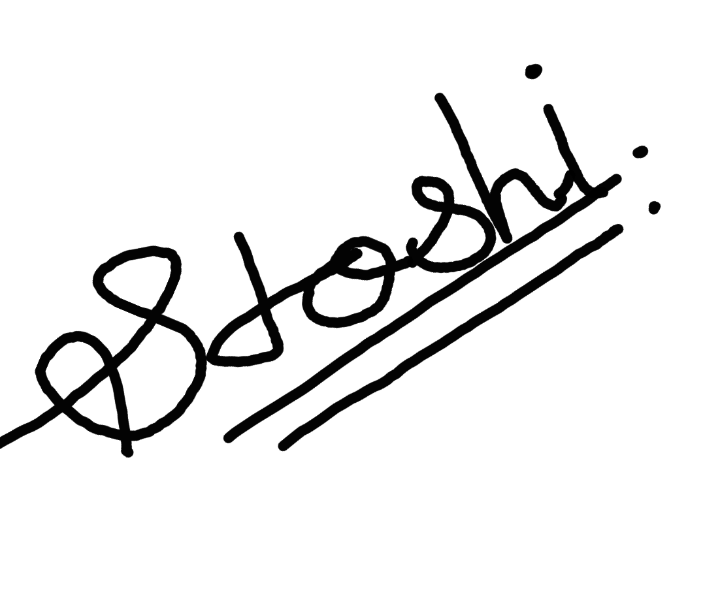
2 | Dinesh Vankhade | BMHC04 | 9325194118 | ddvhankade@gmail.com | 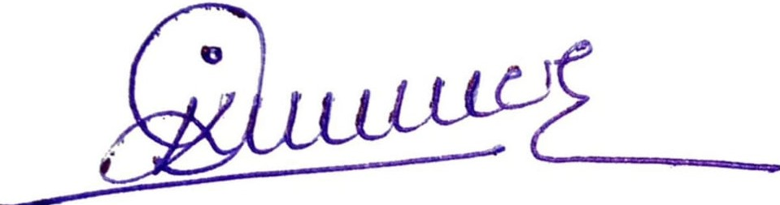
3 | Sneha Koli | BMHC07 | 9689079362 | Snehakoli2013@gmail.com | 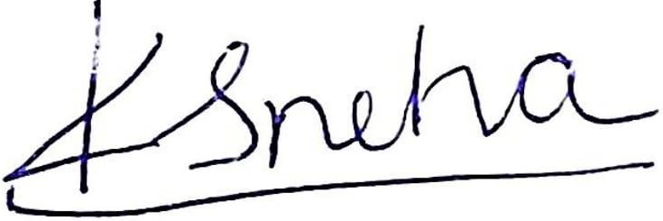
4 | Kirtee Dubal | BMHC11 | 7057091442 | Kirteedubal153@gmail.com | 

- Guide/ Co-guide Details:
Sr. No. | Name of the Faculty | Role | Mobile No. | Email Id
1 | Dr. Sumit desai | Guide | 9283927439 | sumitdesai1234@gmail.com

- Sponsored Project- industry Guide Details (if any):
Sr. No. | Name of industry expert | Mobile No. | Email Id | Name & Full address of industry
1 | Pranav Lad | 9943124084 | Pranv.lad@irobotics.co.in | i Tech Robotics & Automation Pvt. Ltd Gat no-444/2, Success Property Venture, Plot No-49, Nighoje,Tal-Khed,Dist-Pune-410501, Maharashtra 410501

Introduction
The field of robotics has its origin in science fictions. The word robot comes from the CZECH word “robota” means forced labour in 1920. Today in this modern era, we have witnessed a drastic influence of robotics in the technological, manufacturing fields. Robotic technologies are being used widely in the field of education and entertainment purpose. With the progress in technologies, there has been a large advancement with respect to the accessibility of robots. Now-a-days robots can be easily designed and incorporated with multitude of sensors and motors as well as interface with a desktop computer for robust programming experience. Robotic parts can be easily procured at a low cost. Use of Robotic technologies is the best way to interact with the rapidly advancing technological world.
XY Axis drawing robot has artistic abilities of drawing which can be used in interior designing, wall designing, wall painting, logo painting. The robot can make significant influence in training and other educational purposes. The robot is able to draw sketches similar to how human perform with greater precision and accuracy. The drawing robot is designed to work with the help of opensource software Inkscape and Makelangelo. Inkscape provides a platform to input the sketches and then convert them in the form of SVG format. The robot has the capability to draw sketches in a predefined workspace area.
Mechanical parts were designed using CAD tools and then converted into STL file format and printed using 3D printer. Ultimaker Cura is the software which is used to give inputs to the 3d printer to print pen holder and motor brackets. The XY Axis drawing robot has a 2axis control using the stepper motor and the pen is controlled using a servo motor. It uses Inkscape software for drawing images and to create SVG files. SVG files converted into G-code sends these G-code files to microcontroller board through Makelangelo software for controlling the pen/pencil to move in x, y and z directions to draw the image. Arduino software is used to send electrical signal.
The project also contains the upgradation of motor shield for resolving the problem of overheating of motor shield. The main goal of this research is to develop a drawing robot which can draw complex sketches on a paper as well as on wall. Design a mechanism which is easy to operate and install and it should be light weight and low in cost

2. Literature Review
Sr. No. | Name of Author/s | Title of  the Paper | Name of the Journal (Vol. No. Year) | Relevant Findings
01 | 1)Sidharth Tripathi  2)Dev Joshi  3)Beauty sharma | XY Plotter | Volume-6, issue-4, Oct-2018 | For efficient work of robot, they used polarograph server Arduino based program and polar graph processing software.
02 | 1)Mrs. R.Dayna  2)Gunaseelan P | Microctroller based X-Y plotter | Volume.3, issue 3, Apr 2014 | 1)low power consumable microctroller (MSP430) is used. Which consume 3.5v input  2)For better accuracy draper motor is uesd.
03 | 1)Saurabh Sharma  2)Harish  3)S.B Nikam | X Y drawing robot using Arduino | Volume6 issue 2, | To raise and lower the pen spring is used. And stepper motor is used for moving pen.
04 | 1.Rowjatul Zannat Eshita  2.Tanwy Barua  3.Arzon Barua  4.Anik Mahamood Dip | Bluetooth Based Android Controlled Robot | Volume-5, Issue-3, pp-195-199 | To designing a robot that can be operated using Android Apps using Bluetooth sensor
05 | 1.Kaustubh Gawli  2.Parinay Karande  3.Pravin Belos  4.Tushar Bhadirke  5.Akansha Bhargava | Internet of Things (IOT) Based Robotic Arm | Volume: 04 Issue: 03 | Mar -2017 | They controlled robotic arm with of using IOT sensor which integrate mobile and pc

3. Problem Statement
1. Our problem statement is to make a robot which is able to draw any sketch anywhere like wall paper, glass and which will be portable and easy for handling.
2. The XY Axis drawing robot is being implemented to ease the process of sketching and the process of drawing accurate images.
3. The XY Axis drawing robot can be used as a multipurpose application such as carpentry field, architecture field, medical field, etc. & can perform its function with less error.

4. Objectives
1.To design a sketching robot, study of the research papers and collect the relevant information about sketching robot.
2.To Design 3D model of robot which includes assembly drawing & part drawings in the CATIA software.
3. To prepare bill of material for Procurement of required parts for project.
4. To print the 3D parts study the 3D printing process and create STL files of parts.
5. To test the robot find the source code. Manipulate according to requirement and install the software and assemble the parts on the board.
6. To Execute and analysis the result and make a record
5. Proposed Methodology:
This is the proposed methodology of our project which contains research, data collection,
analysis of the project.
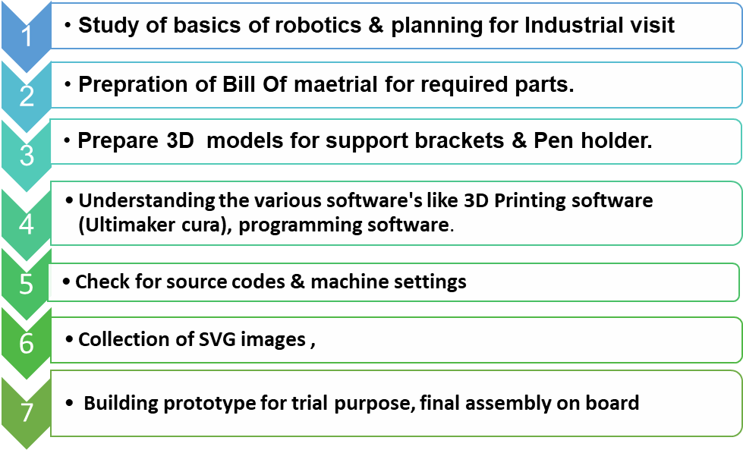 6. Possible outcomes
The possible outcome of the project work carried out during the period.
- Build robot for drawing different types of sketches based on given input.
- Design a robot which is Easy to operate with minimum numbers of steps and it should be portable.
- Design a robot which is light weight and low cost
- Develop multipurpose robot which can be used for other work than sketching as well.
- Write a systematically designed and informative research paper.
7. Novelty
After studying the different research paper, we come across main features of our XY Axis
sketching robot that it can draw on wall and vertical surfaces. it is light in weight. It is low-cost model. One of the important parameters is it is extremely easy to operate.
8. Applications
1. It can be used as Interior designing, wall designing, wall painting, logo painting, etc.
2. By replacing pen can be used as a laser wood cutting of different and complex shapes with cheaper cost
3. It can used in education field to draw a diagram or to write on board while teaching, this will save time and can draw accurately
4. It can be used to enlarge or can be used to make replica of a given drawing, with multiple number of times.
References:
Papers from Journal or Transactions:
1. Sidharth Tripathi, Dev Joshi, Beauty sharma, “XY Plotter”, International Journal of Advances in Science Engineering and Technology, Volume-6, issue-4, Oct-2018
2. Mrs. R. Dayna, Gunaseelan P., “Microcontroller based X-Y plotter”, International Journal of Advanced Research in Electrical, Electronics and Instrumentation Engineering Volume.3, issue 3, Apr 2014.
3. Saurabh Sharma, Harish, S. B Nikam ,“X Y drawing robot using Arduino”, IJIRT, Volume 6 issue 2, July 2019
4. Rowjatul Zannat Eshita, Tanwy Barua , Arzon Barua Anik Mahamood Dip, “ Bluetooth Based Android Controlled Robot” American Journal of Engineering Research , Volume-5, Issue-3, 2016.
Textbook:
Appu Kuttan K.K. , Robotics, I. K. International Publisher, Banglore ,Delhi, 1 oct 2013 .

Name & Sign of Project Guide

